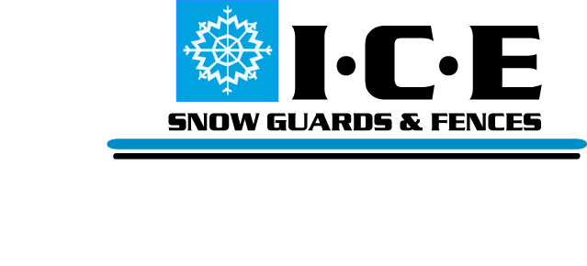
T16 Snow Guard Specification Sheet
PART 1 GENERAL
  - SUMMARY
- Work Includes
1. Install T16 Snow Guard to roof system.
2. Provide necessary components:T16 Snow Guard and Adhesive.
1.2 RELATED SECTIONS
1. Division 7: Thermal and Moisture Protection
2. Section 07320 Roofing Tiles
3. Section 07600 Flashing and Sheet Metal
1.3 SYSTEM
- Components
1. T16 Snow Guard.
2. Butyl Adhesive.
- Design - To be recommended by Manufacturer or Structural Engineer.
1.4 SUBMITTAL - Submit Manufacturers Specifications, recommended layout, product drawings and installation instructions.
1.5 QUALITY ASSURANCE - Installer to be experienced in roofing and snow retention for a minimum of not less than 5 years.
1.6 DELIVERY/STORAGE - Inspect material upon delivery and inform distributer of any damaged or missing items. Protect materials from damage until installation.

PART 2 PRODUCTS
2.1 MANUFACTURER
A. Ice Control Engineering, Inc. - 122 N. 1800 W. Unit #9. Lindon, Utah 84042
Tel. (801) 787-6555; Email: icecontrol@comcast.net; Web: www.icesnowguards.com
2.2 MATERIALS
A. T14 Snow Guard 16 gauge electro galvanized steel.
B. Butyl Adhesive.
2.3 FINISH - TGIC Polyester powder coating

PART 3 EXECUTION
3.1 EXAMINATION - Inspect roof structure to insure it will withstand snow loads. Correct all problems before installation of snow guards.
3.2 INSTALLATION - Install according to architects drawing and manufacturer’s instructions.

